Experiment 2 - Working with Maven

1. Creating a Maven Project
- Step 1: Open Terminal
- Step 2: Generate Project
If there is already a folder named MyMavenApp then change the -DrartifactId value to some other name or delete the MyMavenApp folder.
mvn archetype:generate -DgroupId=com.example -DartifactId=MyMavenApp -DarchetypeArtifactId=maven-archetype-quickstart -DinteractiveMode=false
- Step 3: Navigate to Project Directory
- cd MyMavenApp

2. Maven Project Layout
To visualize the structure of the generated Maven project, you can use the tree command.
If tree is not already installed on your system, run the following command in your terminal:
sudo snap install tree
Then, navigate to your project directory (e.g., cd MyMavenApp) and run:
Tree

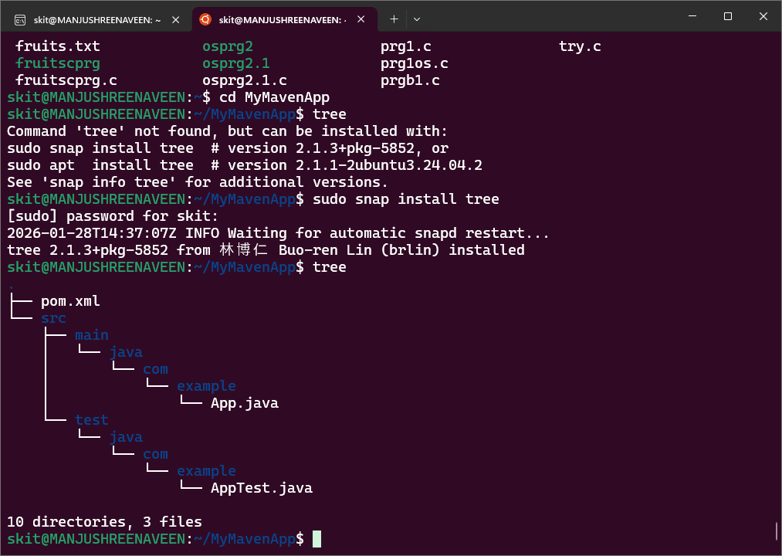

Key files and directories:
- pom.xml
- src/main/java/com/example/App.java
- src/test/java/com/example/AppTest.java

3. Understanding the POM File (pom.xml)

Basic Structure:
- Step 1: Open the pom.xml file
gedit pom.xml
- Step 2: Remove the existing pom.xml file and paste the following
<?xml version="1.0" encoding="UTF-8"?>
<project xmlns="<http://maven.apache.org/POM/4.0.0>"
xmlns:xsi="<http://www.w3.org/2001/XMLSchema-instance>"
xsi:schemaLocation="<http://maven.apache.org/POM/4.0.0> <http://maven.apache.org/xsd/maven-4.0.0.xsd>">

<modelVersion>4.0.0</modelVersion>
<groupId>com.example</groupId>
<artifactId>MyMavenApp</artifactId>
<version>1.0-SNAPSHOT</version>
<packaging>jar</packaging>

<properties>
<!-- Java version -->
<maven.compiler.source>17</maven.compiler.source>
<maven.compiler.target>17</maven.compiler.target>

<!-- JUnit and Surefire versions -->
<junit.jupiter.version>5.10.1</junit.jupiter.version>
<surefire.plugin.version>3.0.0-M7</surefire.plugin.version>
</properties>

<dependencies>
<!-- JUnit 5 API for writing tests -->
<dependency>
<groupId>org.junit.jupiter</groupId>
<artifactId>junit-jupiter-api</artifactId>
<version>${junit.jupiter.version}</version>
<scope>test</scope>
</dependency>

<!-- JUnit 5 Engine for running tests -->
<dependency>
<groupId>org.junit.jupiter</groupId>
<artifactId>junit-jupiter-engine</artifactId>
<version>${junit.jupiter.version}</version>
<scope>test</scope>
</dependency>
</dependencies>

<build>
<plugins>
<!-- Compiler plugin for Java 17 -->
<plugin>
<groupId>org.apache.maven.plugins</groupId>
<artifactId>maven-compiler-plugin</artifactId>
<version>3.8.1</version>
<configuration>
<source>${maven.compiler.source}</source>
<target>${maven.compiler.target}</target>
</configuration>
</plugin>

<!-- Surefire plugin to run JUnit 5 tests -->
<plugin>
<groupId>org.apache.maven.plugins</groupId>
<artifactId>maven-surefire-plugin</artifactId>
<version>${surefire.plugin.version}</version>
<configuration>
<argLine>--add-opens java.base/java.lang=ALL-UNNAMED</argLine>
</configuration>
</plugin>
</plugins>
</build>

</project>

4. Updating the Default Java Files
The Maven archetype generated default main and test Java files. We will now replace their content with the following code.
- Step 1: To open and edit the main application file (App.java), use the following command:
gedit src/main/java/com/example/App.java
Replace the existing content with this code:
package com.example;

public class App {
public String getMessage() {
return "Hello World!";
}

public static void main(String[] args) {
System.out.println(new App().getMessage());
}
}
- Step 2: To open and edit the test file (AppTest.java), use the following command:
gedit src/test/java/com/example/AppTest.java
Replace the existing content with this code:
package com.example;

import org.junit.jupiter.api.Test;
import static org.junit.jupiter.api.Assertions.assertEquals;

class AppTest {

@Test
void testGetMessage() {
App app = new App();
assertEquals("Hello World!", app.getMessage(), "Message should be 'Hello World!'");
}
}

5. Compiling the Project
Now that we've updated the source code, we need to compile the project. This will also run the tests defined in src/test/java. The mvn clean install command cleans the target directory, compiles the source code, runs the tests, and packages the project into a JAR file.
mvn clean install
You should see output indicating that the build was successful and the tests passed.

6. Running the Application
You can run the main class of your application directly using the Maven Exec Plugin.
java -cp target/classes com.example.App
- java: The command to execute a Java class file.
- cp target/classes: This sets the classpath. It tells the Java runtime where to look for compiled .class files. In a standard Maven project, the compiled main classes are placed in the target/classes directory.
- com.example.App: The fully qualified name of the class containing the main method you want to execute.
